**ABOUT THE DATASET**

The Social Network Ads dataset gives the perception of the relationship between age and estimated salaries of persons who purchased the network ads. This dataset comprises 400 data points (rows) and 3 informative columns, namely; 'Age,' 'EstimatedSalary,' and 'Purchased'. It gives an in-depth view of the impact of the ages of persons who purchased or did not purchase the network ads and their estimated salaries. The first 5 rows of the dataset are shown below;

|  |  |  |  |
| --- | --- | --- | --- |
| S/N | Age | EstimatedSalary | Purchased |
| 1 | 19 | 19000 | 0 |
| 2 | 35 | 20000 | 0 |
| 3 | 26 | 43000 | 0 |
| 4 | 27 | 57000 | 0 |
| 5 | 19 | 76000 | 0 |

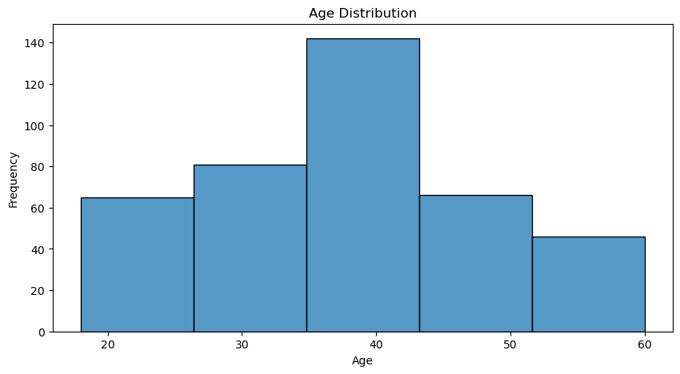

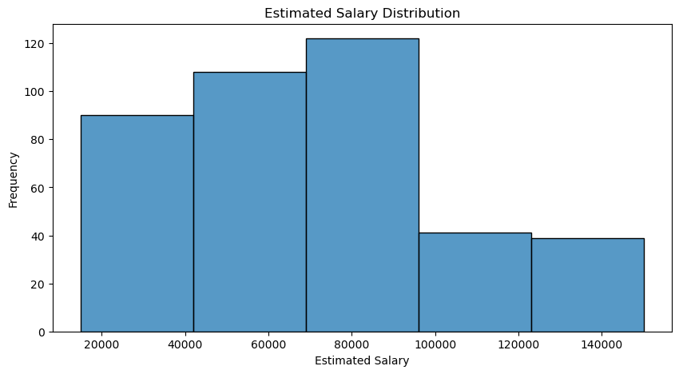

5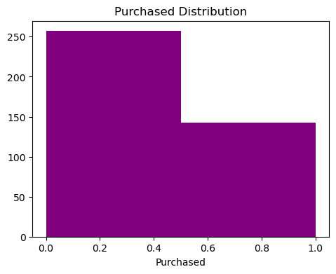

The charts above show the visual display of the distribution of age, estimated salary and purchased.

**Age Distribution:** The age distribution chart shows a normal or center skew pattern which indicates that persons between the age range of 35 to 43 years have the highest frequency in the dataset.

**Estimated Salary Distribution:** The estimated salary distribution chart shows right skew pattern. The chart shows that range of estimated salary from 69,000 to 93,000 have the highest frequency in the dataset.

**Purchased Distribution:** The age distribution chart shows that persons who made a purchase have the highest frequency.

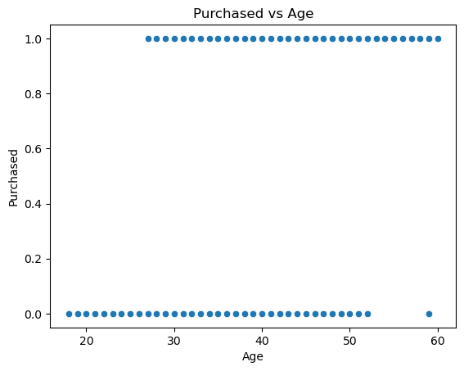 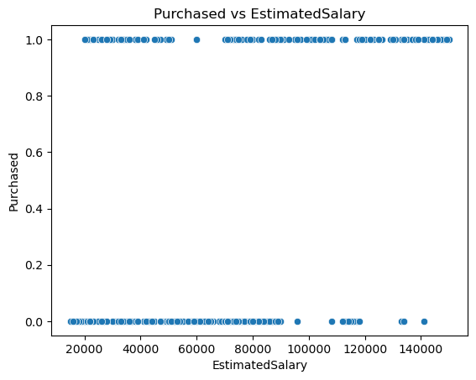

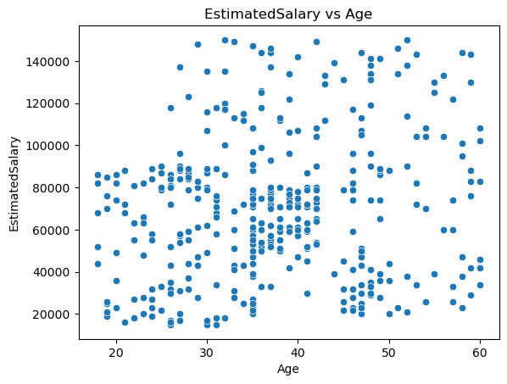

The scatter plots above show the relationships between age, estimated salary and their impacts on purchase of the network ads.

**For Purchased vs Age:** The scatter plot shows that there’s a relationship between the ages of people and their ability to purchase the ads. It shows that persons from the ages of 26 to 60 years purchased the ads and persons below 26 years old did not purchase the ads.

**For Purchased vs EstimatedSalary:** The scatter plot shows that the salaries of persons who purchased the ads fall more under 20,000 to 50,000, 68,000 to 108,000, 111,000 and 112 to 156,000. For those who did not make a purchase,their salaries fall under 15,000 to 91,000, 95,000, 109,000, 111,000 to 119,000, 134,000 and 142,000.

**For EstimatedSalary vs Age:** The scatter plot shows that persons between the age range of 17 to 26 years only earn salaries ranging from 12,000 to 90,000 while persons between the age range of 27 to 61 years earn salaries ranging from12,000 to 151,000.

This indicates that persons between the age range of 27 years and above earn more salaries and purchased more while persons below 26 years old earn less salaries and purchased less.This means that those who purchased the ads are older than those who did not purchase. Also, those who purchased earn more salary than those who did not purchase, indicating the impact of age and salary on purchase of the ads.

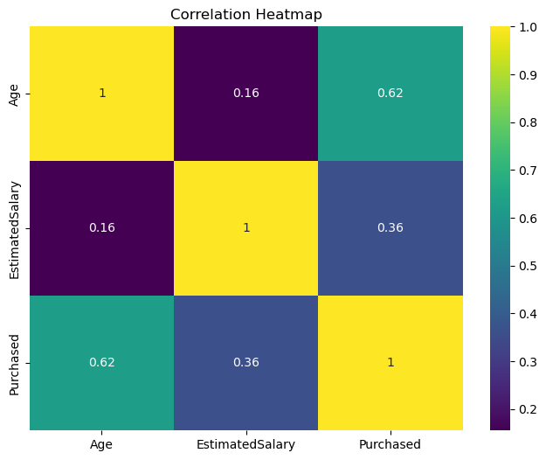

The Correlation Heatmap above shows correlation between different variables (Age, EstimatedSalary and Purchased).

Age and Purchased have a strong positive correlation of 62%. This points out that purchase tends to increase as the age of persons increase.

EstimatedSalary and Purchased have a moderate positive correlation of about 36% which demonstrates that estimated salary and purchase have a moderate positive relationship. An increase in salary is associated with an increase in purchase.

Age and EstimatedSalary have a weaker positive correlation of 16% which demonstrates that the relationship between age and estimated salary is weak.

**SUMMARY**

In summary, this dataset gives useful insights into the impact of age and estimated salaries of persons on their ability to purchase the social network ads. Age shows the strongest correlation with purchase, followed by estimated salary. These findings can serve as a guide on the ages and estimated salaries of persons to put into consideration when creating the social networks in order to boost sales performance.